Client

X Rotageek

Sub Title

Contents

Rotageek – The New Market Leader 3
Intro text headline 3
Table Format 4
Solutions 5
Optimised WFM Solution 5
Solutions - Health 6
Optimised WFM Solution 6

Rotageek – The New Market Leader

Rotageek are delighted to be able to provide this final cost proposal for The Range’s consideration. We believe our product and services represent the best possible solution as well as value for money to both exceed The Range’s WFM requirements and ROI expectations.

The Rotageek business model is completely unique in the WFM market. We offer guaranteed fixed price implementation, no additional costs for any changes in the project scope, unlimited employee user licences and no additional charges for future integrations or cloud service changes.

But we don’t want to stop there…. We also want to ensure that you are getting the absolute best value for money and as such we stand by our commitment to guarantee being 10% cheaper than our competitor across the Total Cost of ownership (Implementation, Subscription and Hardware) NOT just subscription!

Intro text headline
Rotageek are delighted to be able to provide this final cost proposal for The Range’s consideration. We believe our product and services represent the best possible solution as well as value for money to both exceed The Range’s WFM requirements and ROI expectations.

The Rotageek business model is completely unique in the WFM market. We offer guaranteed fixed price implementation, no additional costs for any changes in the project scope, unlimited employee user licenses and no additional charges for future integrations or cloud service changes.

But we don’t want to stop there…. We also want to ensure that you are getting the absolute best value for money and as such we stand by our commitment to guarantee being 10% cheaper than our competitor across the Total Cost of ownership (Implementation, Subscription and Hardware) NOT just subscription!

Table Format

Header | Header | Header | Header
Line entry | £13,000.00 | £13,000.00 | £13,000.00
Line entry | £13,000.00 | £13,000.00 | £13,000.00
Line entry | £13,000.00 | £13,000.00 | £13,000.00
Line entry | £13,000.00 | £13,000.00 | £13,000.00
Line entry | £13,000.00 | £13,000.00 | £13,000.00
TOTAL | £13,000.00 | £13,000.00 | £13,000.00

Solutions

Rotageek is the scheduling solution of choice for some of the world’s leading retailers including Iceland, Caffe Nero, McColls, Lush Cosmetics, Dune London, Gap, The Perfume Shop, Dreams and Pets at Home.

Rotageek’s digital core solution reduces admin at head office by up to 80%, whilst improving the employee self-serve experience.

Furthermore, our intelligent, Machine Learning-driven forecasting and Auto scheduling solutions perfectly align labour to child-demand, increasing parent/carer and employee satisfaction, overall attractiveness of Busy Bees to new parents, improving profitability and driving efficiencies across board.

Optimised WFM Solution

Includes:

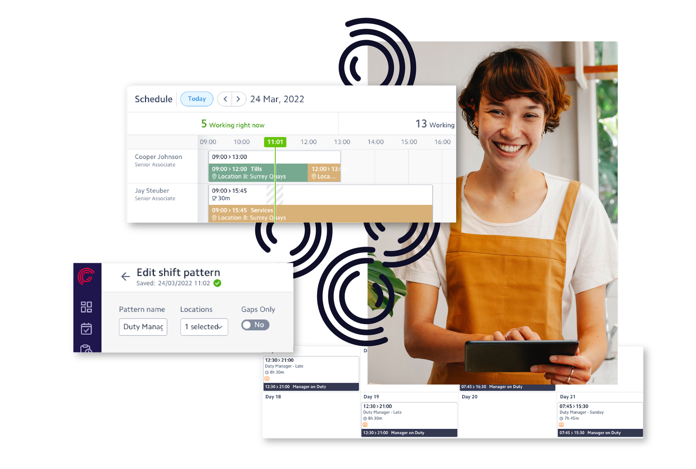
- Digital scheduling creation tools
- Fairness & employee preferences
- Real-time compliance checks & alerts
- Colleague scheduling profiles
- Leave management
- Colleague self-service mobile app
- Push notifications and email alerts
- Gap shifts and shift swaps
- Timesheets
- Up to 8 bespoke configured dashboards & reports
- 1-click Auto scheduling
- Timeclock connectivity

Solutions - Healthcare
Rotageek is the scheduling solution of choice for some of the world’s leading retailers including Iceland, Caffe Nero, McColls, Lush Cosmetics, Dune London, Gap, The Perfume Shop, Dreams and Pets at Home.

Rotageek’s digital core solution reduces admin at head office by up to 80%, whilst improving the employee self-serve experience.

Furthermore, our intelligent, Machine Learning-driven forecasting and Auto scheduling solutions perfectly align labour to child-demand, increasing parent/carer and employee satisfaction, overall attractiveness of Busy Bees to new parents, improving profitability and driving efficiencies across board.

Optimised WFM Solution

Includes:

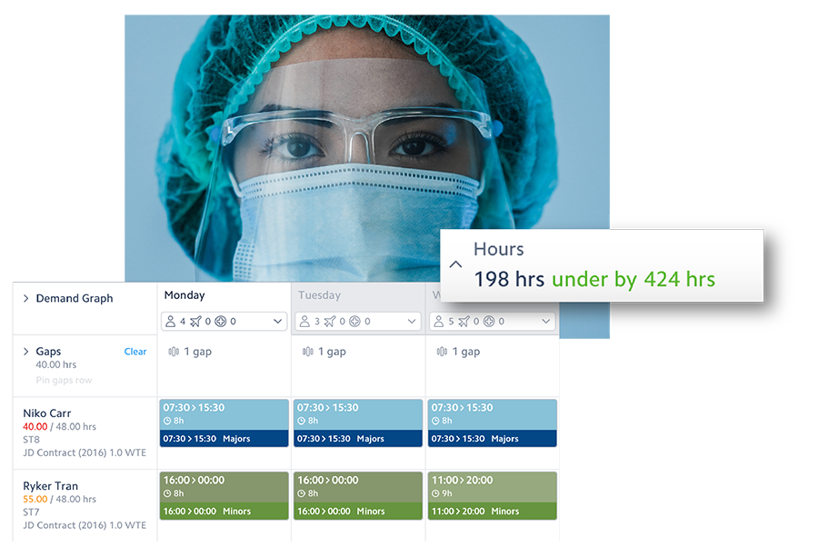
- Digital scheduling creation tools
- Fairness & employee preferences
- Real-time compliance checks & alerts
- Colleague scheduling profiles
- Leave management
- Colleague self-service mobile app
- Push notifications and email alerts
- Gap shifts and shift swaps
- Timesheets
- Up to 8 bespoke configured dashboards & reports
- 1-click Auto scheduling
- Timeclock connectivity

Thank you.

www.rotageek.com

RotaGeek Limited is a company registered in England and Wales with the company number 06783810 and registered address of 71-75 Shelton Street, London WC2H 9JQ

